# Introduction

The assignment is targeted to test the skills of the candidate in CSS.

# Objective

This assignment will help master the concepts of CSS.

# Pre-requisites

Concepts of HTML.

# Associated Data Files

Completed HTML layout of the previous assignment.

Make sure to complete the previous assignment before starting this.

# Problem Statement

1. Create a document where you use the 3 ways of attaching CSS.
   1. Styling using inline styles.
   2. Styling using embedded styles.
   3. Styling using an external style sheet.
2. Add content to the CSS to display the following:

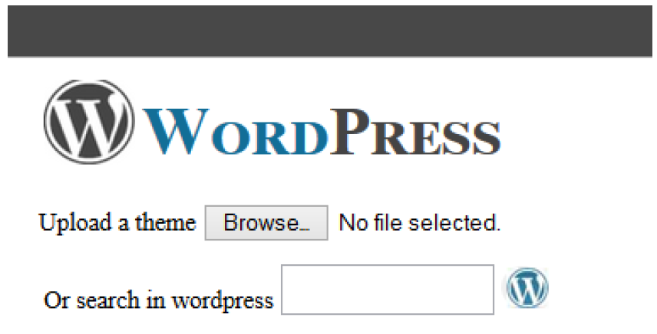

1. To the existing HTML add a form element and design it using CSS as shown in the below image.

